HTML Quiz

**Theory**

Q1) Which of the following browser supports HTML5 in its latest version?

A - Mozilla Firefox

B - Opera

C - Both of the above

D - None of the above

Q2) **<title>…</title>** tag must be within…

A - Title

B - Form

C - Header

D - Body

Q3) Is **<keygen>** a valid HTML5 tag?

Yes/No

Q4) Does the **<bdo>** tag change the direction of text?

Yes/No

Q5) If you have a page of search results and want to highlight the search term, what HTML tag would you use?

A - **<strong>**

B - **<mark>**

C - **<em>**

D - **<highlight>**

Q6) In which situation would you use the **<small>** tag?

A - When you want to create subheading after a **<h1>** element

B - When you want to add copyright information inside a **<footer>** element

C - Both

D - Neither

Q7) Consider the following HTML. What does the **scoped** attribute do?

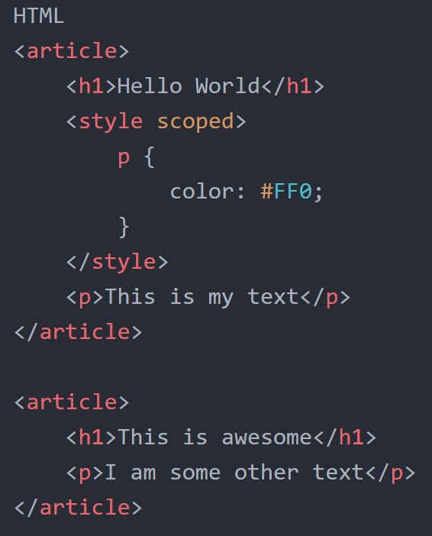

A - Applies style rules to elements succeeding it, but with the same parent element

B - Applies style rules to all children of the scoped parent element

C - Applies style rules to IE browsers only

D - None of the Above

Q8) What is the correct HTML for adding a background colour?

A -



B -



C -



D -



Q9) What is the correct HTML for adding a background colour?

A -



B -

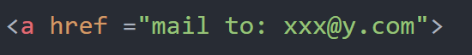

C -



D -

None of the Above

Q10) Is this code valid? Yes/No

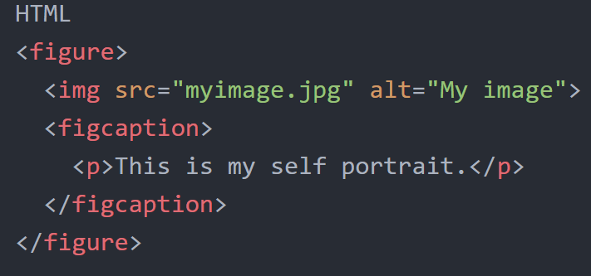

**Code Text**

**Theory**

**Q7**

<article>

<h1>Hello World</h1>

<style scoped>

p {

color: #FF0;

}

</style>

<p>This is my text</p>

</article>

<article>

<h1>This is awesome</h1>

<p>I am some other text</p>

</article>

**Q8**

A.

<background>yellow<Background>

B.

<body color = "yellow">

C.

<body bg color = "yellow">

D.

<body bg ="yellow">

**Q9**

A.

<mail href +"xxx@y.com">

B.

<a href ="mail to: xxx@y.com">

C.

<a href = "xxx@y.com">

**Q10**

<figure>

<img src="myimage.jpg" alt="My image">

<figcaption>

<p>This is my self portrait.</p>

</figcaption>

</figure>